**Number Systems Used In Computers**

Complete the following table:

|  |  |  |  |
| --- | --- | --- | --- |
| **Number System** | **Number Base** | **Digits Used** | **Purpose** |
| Decimal | Base 10 | 0 to 9 | Used for communicating with human users |
| Binary |  |  |  |
| Octal |  |  |  |
| Hexadecimal |  |  |  |

**Decimal vs. Binary System**

Write down the definition of a **Bit** in computer terminology:

Complete the following table:

|  |  |  |
| --- | --- | --- |
|  | **Decimal System** | **Binary System** |
| Uses Digits |  |  |
| Addition Examples |  |  |
| Powers of 10 |  |  |
| Evaluate 111 |  |  |

**Powers of 2**

|  |  |  |  |  |
| --- | --- | --- | --- | --- |
| **Power  of 2** | **Decimal Value** | **Integer Range** | **Number  of Bits** | **Computer Binary** |
| 21 | 2 | 0 - 1 | 1 | 0001 |
| 22 | 4 | 0 - 3 | 2 | 0011 |
| 23 |  |  |  | 0111 |
| 24 |  |  |  | 1111 |
| 25 |  |  |  | 0001 1111 |
| 26 |  |  |  | 0011 1111 |
| 27 |  |  |  | 0111 1111 |
| 28 | 256 | 0 - 255 | 8 | 1111 1111 |
| 29 |  |  |  | 0001 1111 1111 |
| 210 |  |  |  | 0011 1111 1111 |
| 211 |  |  |  | 0111 1111 1111 |
| 212 |  |  |  | 1111 1111 1111 |
| 213 |  |  |  | 0001 1111 1111 1111 |
| 214 |  |  |  | 0011 1111 1111 1111 |
| 215 |  |  |  | 0111 1111 1111 1111 |
| 216 | 65,536 | 0 – 65,535 | 16 | 1111 1111 1111 1111 |

**Conversions**

Convert the following binary numbers to decimal:

11 binary =

101 binary =

1010 binary =

Convert the following decimal numbers to binary:

6 decimal =

13 decimal =

**Binary Addition**

Add the following binary numbers. (verify your answers using decimal)

|  |  |  |  |  |  |  |  |  |  |  |  |  |  |
| --- | --- | --- | --- | --- | --- | --- | --- | --- | --- | --- | --- | --- | --- |
| |  |  | | --- | --- | | **0101** | **(decimal 5)** | | **+ 0010** | **(decimal 2)** | |  |  | | |  |  | | --- | --- | | **0101** | **(decimal 5)** | | **+ 1010** | **(decimal 10)** | |  |  | |
| |  |  | | --- | --- | | **0011** | **(decimal 3)** | | **+ 0010** | **(decimal 2)** | |  |  | | |  |  | | --- | --- | | **0110** | **(decimal 6)** | | **+ 0011** | **(decimal 3)** | |  |  | |

**Prefixes**

* Kilo (K) means __________________ Multiply by x______________
* Mega (M) means _________________ Multiply by x______________

* Giga (G) means __________________ Multiply by x______________
* Tera (T) means __________________ Multiply by x______________

**Examples**

1. 64 Kbps (Kilo-bits per seconds) = ___________________ bps (bits per second)
2. 256 Giga-bytes = _________________________________ bytes
3. 256 Giga-bytes = _________________________________ bits

**Computer Memory Structures**

|  |  |  |  |
| --- | --- | --- | --- |
| **Structure** | **Number of Bits** | **Largest Value** | **Used For...** |
| Bit |  |  |  |
| Byte |  |  |  |
| Word |  |  |  |
| Short Integer |  |  |  |
| Double Word |  |  |  |
| Long Integer |  |  |  |
| Memory Address |  |  |  |

**Memory Organization**

Bit (Binary Digit)

* One bit can have a value of ________ or _________
* Or a Boolean logic value of ________ or _________

|  |  |  |  |  |  |  |  |  |  |  |  |  |  |  |  |  |  |  |  |
| --- | --- | --- | --- | --- | --- | --- | --- | --- | --- | --- | --- | --- | --- | --- | --- | --- | --- | --- | --- |
| |  |  |  |  | | --- | --- | --- | --- | | 0 | 0 | 0 | 0 | | |  |  |  |  | | --- | --- | --- | --- | | 0 | 0 | 0 | 0 | | |  |  |  |  | | --- | --- | --- | --- | | 0 | 0 | 0 | 0 | | |  |  |  |  | | --- | --- | --- | --- | | 0 | 0 | 0 | 0 | |

Byte (8 bits)

* One byte has a size of ________ bits
* A byte has an unsigned integer value range from 0 to _________

|  |  |  |  |  |  |  |  |  |  |  |  |  |  |  |  |  |  |  |  |
| --- | --- | --- | --- | --- | --- | --- | --- | --- | --- | --- | --- | --- | --- | --- | --- | --- | --- | --- | --- |
| |  |  |  |  | | --- | --- | --- | --- | | 0 | 0 | 0 | 0 | | |  |  |  |  | | --- | --- | --- | --- | | 0 | 0 | 0 | 0 | | |  |  |  |  | | --- | --- | --- | --- | | 0 | 0 | 0 | 0 | | |  |  |  |  | | --- | --- | --- | --- | | 0 | 0 | 0 | 0 | |

Word (2 bytes or 16 bits)

* One word has a size of ________ bits
* One word has a size of ________ bytes
* A byte has an unsigned integer value range from 0 to _________

|  |  |  |  |  |  |  |  |  |  |  |  |  |  |  |  |  |  |  |  |
| --- | --- | --- | --- | --- | --- | --- | --- | --- | --- | --- | --- | --- | --- | --- | --- | --- | --- | --- | --- |
| |  |  |  |  | | --- | --- | --- | --- | | 0 | 0 | 0 | 0 | | |  |  |  |  | | --- | --- | --- | --- | | 0 | 0 | 0 | 0 | | |  |  |  |  | | --- | --- | --- | --- | | 0 | 0 | 0 | 0 | | |  |  |  |  | | --- | --- | --- | --- | | 0 | 0 | 0 | 0 | |
|  | |  | |

Long or Double Word (4 bytes or 32 bits)

* One Long word has a size of ________ words
* A Long word has an unsigned integer value range from 0 to _________

|  |  |  |  |  |  |  |  |  |  |  |  |  |  |  |  |  |  |  |  |
| --- | --- | --- | --- | --- | --- | --- | --- | --- | --- | --- | --- | --- | --- | --- | --- | --- | --- | --- | --- |
| |  |  |  |  | | --- | --- | --- | --- | | 0 | 0 | 0 | 0 | | |  |  |  |  | | --- | --- | --- | --- | | 0 | 0 | 0 | 0 | | |  |  |  |  | | --- | --- | --- | --- | | 0 | 0 | 0 | 0 | | |  |  |  |  | | --- | --- | --- | --- | | 0 | 0 | 0 | 0 | |
|  | |  | |
| |  |  |  |  | | --- | --- | --- | --- | | 0 | 0 | 0 | 0 | | |  |  |  |  | | --- | --- | --- | --- | | 0 | 0 | 0 | 0 | | |  |  |  |  | | --- | --- | --- | --- | | 0 | 0 | 0 | 0 | | |  |  |  |  | | --- | --- | --- | --- | | 0 | 0 | 0 | 0 | |
|  | |  | |

**Questions**

1. What is the smallest memory object that can represent a character of information?
   1. Think… How many upper case letters in the alphabet (A to Z)?
   2. Think… How many lower case letters in the alphabet (a to z)?
   3. Think… How many number digits (0 to 9)?
   4. Think… How many punctuation marks?
   5. Add them all up

26 + 26 + 10 + 14 = 76 A byte can hold 256 integers so it can hold all of these and more.

1. Research the ASCII characters set. What is it and how is it related to computer memory?

The ASCII character set is a set of characters with indexes saved as numbers. It goes from 0 – 127 in normal ASCII but extended ASCII has 0 – 255 since ASCII uses 1 byte per character.

1. How are strings of characters (Google “String”) represented in computer memory?

Strings are either capped at a certain length to be represented in certain multiples of bytes or are dynamically sized which allows a string to hold as my characters as it needs by changing the specified space maximum from byte to KB to GB etc.

1. How are negative integers represented in computer memory? (Include a diagram)

Positive integers are represented as a number with the 0’s in front of it. Negative integers are represented with the number and then the 0’s afterward.

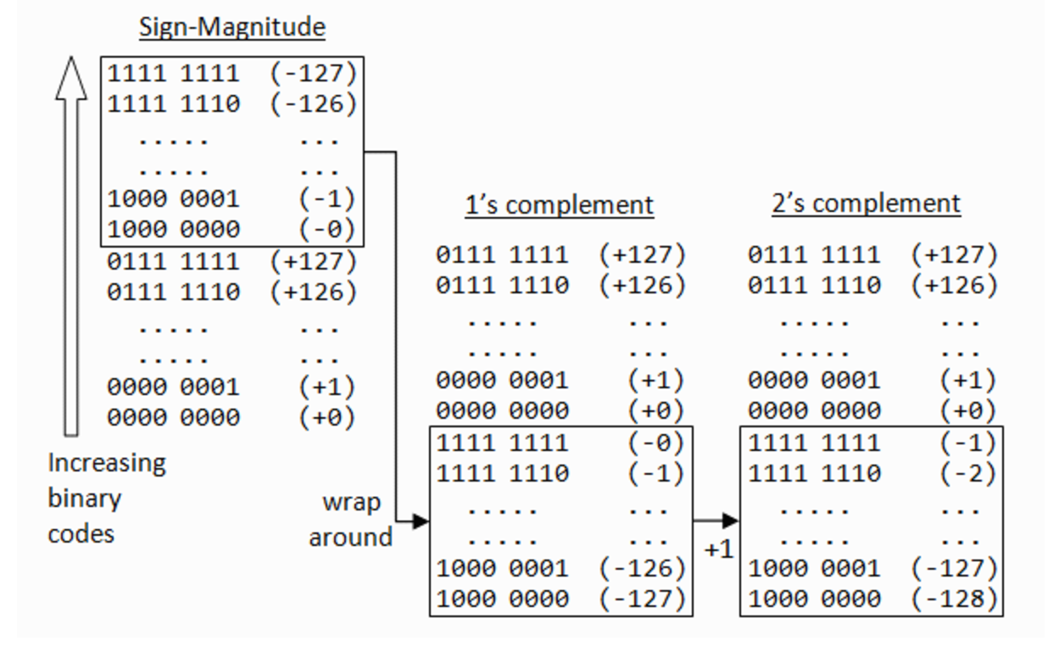

1. How are decimal numbers (Google “Floating Point”) represented in computer memory? (Include a diagram)

Floats are 64 bits and are stored by storing an exponent and its complement to represent a fraction and do math with these.

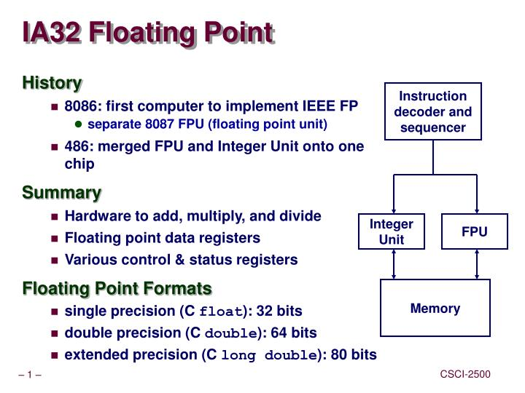

1. A Pixel is computer memory structure used to store image information. How is a Pixel represented in memory? (Include a diagram).

The pixel is a square of binary information which, with a collection of 0s and 1s in a square pattern determines what colour to display. 